WHAT IF I HAD TO DRIVE MY BOAT?

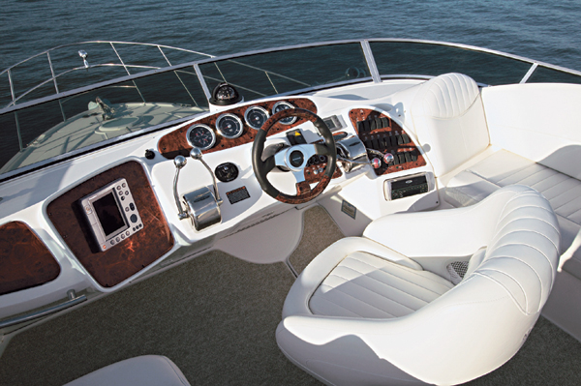

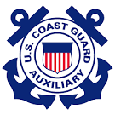
SUDDENLY IN COMMAND

~ The Captain is unable to continue due to injury or some other problem. We intend to help you take charge, assess the situation, establish priorities, protect life and property, get help and move your boat…

IF YOU HAVE TO

COURSE OBJECTIVES

TOPICS:
- Emergency Communication
- Identifying – “WHERE AM I?”
- Critical Thinking
- Protecting Life and Property
- Starting Your Boat/Vessel
- Operating at Slow Speeds
- Simple Boat/Vessel Handling
- Basics of Anchoring

The rest of this document is designed as a lesson plan for on-going training and preparation.

EMERGENCY QUESTIONS
- Where are you? Location? How do you know?

- Can you call for help?

- Did you file a float plan?

- Where is the emergency gear and can you use it?

IN AN EMERGENCY
- Stay Calm

- Get control of the vessel… throttle.
- DO NOT turn engine off

- Assist any person that is injured

- Signal MAYDAY on Channel 16

- Be ready with location and description
CHECKLIST

- Throttle, Gearshift, Gauges

- Start and Stop Engine

- Steer Boat/Vessel

- Anchor Boat/Vessel

- Bilge Pump

- Radio Use

- Where is the fire extinguisher, life jackets, flares, dewatering equipment, anchor, First Aid kit?

- Have you taken First Aid and/or CPR?

- Know every ones medical condition

ALCOHOL - #1 Cause of Boating Accidents

RESPONSE
- How critical is the situation?

- Do you need help? Distress Signal or Radio Use

- What is the first priority? Who does it?

- Stabilize the situation… life jackets on and brief everyone as to the situation at hand.

RADIO
- Channel 16 is monitored by the US Coast Guard

- RESCUE 21

- MAYDAY Call

- Digital Selective Calling (DSC)

- MMSI Number

- Cell Phone

DRILLS

- Talk and Walk – talk it over and walk (practice) it

- Man Overboard (MOB)

- Communication (COMS)

- Distress Signals

- Fire

- Collision

- Grounding

Radio CHECK LIST

- USING THE RADIO:
  - Make Sure It is On __________________________
  - Adjust the Squelch __________________________
  - Channel Selection __________________________
  - Power Level (1, 5, 25 Watts) __________________
  - Location of “Talk” button ______________________
  - Push the Button and Talk into Microphone
  - Say “Over” when you are finished talking and expect a reply back

  - Say “Out” if you are finished and are done with the communication.
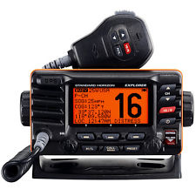

2. DECLARING AN EMERGENCY: (Follow the Steps to use Radio)
2.1 Make sure you’re on Channel 16
2.2 Push the “Talk” button and say: MAYDAY, MAYDAY, MAYDAY this is vessel ______________ declaring a MAYDAY.
2.3 Then state the Nature of the Emergency
_________________________________________
2.4 State Where you are Located…
GPS Coordinates: ___________________________
River MM: _________________________________
Side of River: _______________________________
Other Location Information: ____________________
2.5 State the Number of People on Board ____________
2.6 State the Description of the Boat…
Length: ____________________________________
Color: _____________________________________
Name: ____________________________________
2.7 Then Repeat: “MAYDAY, MAYDAY, MAYDAY, this is vessel ___________ declaring a MAYDAY, “Over”
2.8 Listen to the Radio
  - Respond to the US Coast Guard on the Radio
- STARTING THE BOAT:
  - Find the Key and Prepare for Start 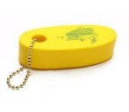
  - Turn on the Blower and Run it for Four Minutes
  - LIST NEEDED STEPS
__________________________________________
__________________________________________
__________________________________________
__________________________________________
__________________________________________
__________________________________________
_____________________________________

