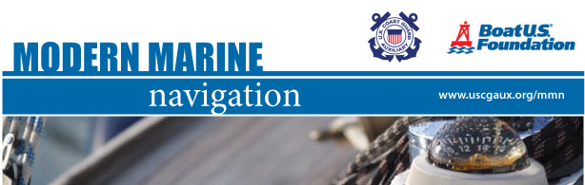
The U.S. Coast Guard Auxiliary and Boat U.S. Foundation are pleased to present Modern Marine Navigation, an on-line education program for boaters.
INTRODUCING the Modern Marine Navigation on-line course. It is a fully electronic on-line interactive instructional training program, written by the staff of the U.S. Coast Guard Auxiliary, vetted by the U.S. Coast Guard and produced and distributed in partnership with the Boat U.S. Foundation.
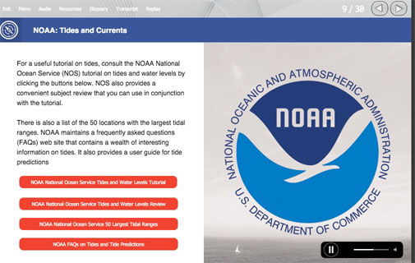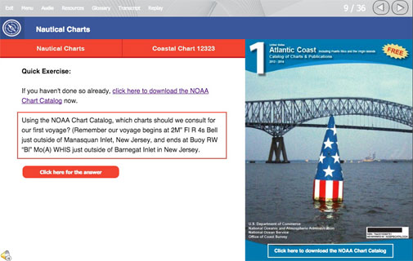

Modern Marine Navigation online self-study course costs $40.00
and is available at www.cgaux.org/mmn
This course is the GOLD STANDARD for on-line navigational courses

For more information on this new educational tool go to: www.cgaux.org/mmn
or contact your local U.S. Coast Guard Auxiliary Flotilla.

USE THIS PROMO CODE for an additional 10% savings on your purchase.

